An IoT-Enabled VOC-Based Biosafe Food Preservation and Spoilage Prediction System

Dr. Ajeet Kumar Srivastava
Assistant Professor, Dept. of Biotechnology
RV College of Engineering
Bengaluru, India

Anurag
Dept. of Electronics & Communication Eng.
RV College of Engineering
Bengaluru, India

Amrut R
Dept. of Electronics & Communication Eng.
RV College of Engineering
Bengaluru, India

Bhavesh S
Dept. of Electronics & Communication Eng.
RV College of Engineering
Bengaluru, India

Abstract: Food spoilage is a major issue in households and small-scale food storage environments due to the absence of continuous monitoring of food quality. Conventional preservation systems mainly rely on cooling and do not provide information about the biological condition of stored food. In this research, a biosafe food spoilage monitoring and preservation system is proposed to detect early food spoilage using volatile organic compound (VOC) sensing combined with basic environmental control. The system employs an Arduino-based microcontroller integrated with a low-cost MQ-2 non-selective gas sensor to monitor relative changes in spoilage-related volatile gases generated due to microbial activity. A Spoilage Prediction Index (SPI) is formulated using trend-based gas sensor data to estimate spoilage progression. Temperature regulation is implemented using a Peltier module to stabilize the storage environment and slow degradation. Experimental testing with perishable food items demonstrates that the system can identify spoilage trends prior to visible degradation and contribute to shelf-life extension. The system architecture is designed to support future IoT-based remote monitoring, while the present implementation focuses on local data acquisition and analysis. The proposed system is low-cost, simple to implement, and suitable for small-scale food safety applications.
Index Terms: Food Spoilage Detection, VOC Sensors, MQ-2 Gas Sensor, Arduino, Spoilage Prediction Index, Smart Food Storage.
Introduction
- Food Spoilage as a Biological and Safety Concern:
Food spoilage is a natural biological process resulting from microbial growth and biochemical degradation of organic components present in food. Bacteria, fungi, and yeasts metabolize carbohydrates, proteins, and fats, leading to the formation of gases such as volatile organic compounds (VOCs), carbon dioxide (CO₂), ammonia, and ethylene. These metabolic by-products accumulate before visible signs of spoilage such as discoloration, texture change, or mould formation become apparent. In domestic households, street-food environments, and small-scale storage facilities, food is often stored without continuous quality monitoring. Spoiled food not only results in economic loss but also poses serious health risks due to foodborne pathogens. Despite this, most food preservation practices rely primarily on refrigeration or passive storage methods and do not provide information about the underlying biological condition of stored food..
B. Limitations of Conventional Food Preservation Systems:

Conventional food preservation systems primarily focus on controlling temperature to slow microbial growth. While refrigeration reduces the rate of spoilage, it does not completely inhibit microbial activity. More importantly, such systems do not provide any indication of when food is approaching unsafe conditions. Existing smart storage solutions largely monitor temperature and humidity, which are indirect indicators of spoilage. A food item may remain within acceptable environmental limits while undergoing internal biological degradation. Visual inspection and smell-based judgment are subjective and often detect spoilage only after significant deterioration has occurred. Therefore, there is a need for monitoring methods that can detect spoilage at an early stage by observing biological indicators rather than relying solely on environmental parameters.

C. Role of VOC Sensing in Spoilage Detection
Volatile organic compounds released during microbial metabolism provide a direct indication of food degradation. The concentration and rate of increase of these gases correlate strongly with microbial activity. Gas sensors have been widely used in laboratory studies and electronic-nose systems to analyze food freshness. Low-cost MQ-series gas sensors are sensitive to a mixture of spoilage-related gases, including alcohol vapors and other volatile compounds produced during decomposition. Although these sensors do not offer selective gas identification, they are effective for detecting relative changes in gas concentration over time. This makes them suitable for early spoilage trend detection when combined with appropriate data processing techniques. However, gas concentration alone may not fully characterize spoilage behavior, as microbial activity is influenced by surrounding storage conditions.
D. Objectives and Scope of the Proposed System:

This This research aims to develop a low-cost food spoilage monitoring and preservation system that integrates VOC sensing with basic environmental control to detect early spoilage trends. The system employs an Arduino-based microcontroller for sensor data acquisition and local processing, using an MQ-2 non-selective gas sensor to monitor relative changes in spoilage-related volatile gases generated due to microbial activity. A Spoilage Prediction Index (SPI) is introduced to combine gas sensor trends into a single quantitative metric representing spoilage progression. Unlike conventional threshold-based approaches, the SPI provides a gradual indication of spoilage development. In addition, a Peltier-based thermal regulation module is used to stabilize the storage environment and slow degradation. The system architecture is designed to support future IoT-based remote monitoring, although the current implementation focuses on local data analysis. The scope of this work is limited to small-scale food storage applications such as households and vendor setups, with emphasis on spoilage trend prediction rather than pathogen identification. Experimental validation is performed using commonly consumed perishable food items to demonstrate practical feasibility.

II. Theoretical Framework

A. Biological Basis of Food Spoilage:

Food spoilage originates from the biochemical activity of microorganisms that colonize food surfaces during handling, storage, and exposure to the environment. These microorganisms, including bacteria, yeasts, and molds, utilize nutrients such as carbohydrates, proteins, and lipids as energy sources. Through enzymatic reactions, these macromolecules are broken down into simpler compounds, resulting in chemical and structural changes within the food matrix. As microbial metabolism progresses, the quality and safety of food deteriorate due to nutrient loss, texture changes, and the formation of undesirable compounds. A key outcome of microbial metabolism is the generation of gaseous by-products. These include volatile organic compounds (VOCs), alcohol vapors, and other decomposition-related gases depending on the type of food and dominant microbial species. Unlike visible spoilage indicators, these biochemical emissions begin at an early stage of degradation. Therefore, monitoring gaseous by-products of microbial metabolism provides a direct and early representation of spoilage activity, forming the biological foundation of gas-based food quality assessment
B. VOC Generation and Its Relation to Microbial Activity:

Volatile organic compounds are low-molecular-weight substances that readily evaporate at ambient temperatures. During food degradation, VOCs are produced through multiple biochemical pathways. Protein-rich foods generate nitrogen-containing volatile compounds, carbohydrate-rich foods produce alcohols and organic acids through fermentation, and lipid degradation results in aldehydes and ketones. Although the exact composition of emitted gases varies across food types, the overall concentration of volatile gases increases consistently as spoilage progresses. The rate of VOC generation is closely linked to microbial growth rate. As microbial populations increase, metabolic activity intensifies, leading to accelerated gas emission. This relationship makes relative changes in gas concentration a reliable proxy for assessing spoilage progression, particularly in low-cost, trend-based monitoring systems.

C. Gas Accumulation in Enclosed Storage Environments:
In open environments, spoilage-related gases disperse rapidly into the surrounding atmosphere and are difficult to quantify. In contrast, enclosed or semi-enclosed storage environments allow these gases to accumulate over time. This accumulation leads to measurable changes in gas concentration that directly reflect ongoing microbial activity within the stored food. The rate of accumulation depends on factors such as food type, microbial load, enclosure volume, and air exchange rate. Enclosed storage conditions therefore provide favorable circumstances for gas-based spoilage monitoring. Continuous observation of gas concentration trends in such environments enables early detection of spoilage progression before external sensory indicators become apparent.

D. Gas Sensor Response Characteristics:
Semiconductor-based gas sensors, such as MQ-series sensors, operate on the principle of resistance variation in the presence of reducing gases. These sensors contain a heated sensing element whose electrical conductivity change when exposed to combustible or volatile gases. The MQ-2 sensor is a non-selective gas sensor that responds to a mixture of volatile and combustible gases commonly produced during food fermentation and decomposition. Although such sensors do not provide selective identification of individual chemical compounds, they are well suited for detecting relative changes in overall gas concentration. For food spoilage monitoring, trend-based sensing is more important than absolute gas quantification. The primary objective is to observe increasing biological activity rather than to identify specific chemical species, making non-selective gas sensors suitable for early warning applications.

E. Influence of Temperature and Humidity on Spoilage Dynamics:
Microbial activity is influenced by environmental conditions, particularly temperature and humidity. Temperature affects enzymatic reaction rates and microbial reproduction, with higher temperatures accelerating spoilage and lower temperatures slowing metabolic processes. Humidity determines moisture availability, which is essential for microbial survival and proliferation, especially in high-moisture food items. While the proposed system primarily relies on gas sensing for spoilage prediction, basic environmental control is employed to slow degradation and stabilize storage conditions. Understanding the influence of temperature and humidity provides contextual support for interpreting gas sensor trends, even when spoilage prediction is driven mainly by VOC behavior.

F. Multi-Parameter Spoilage Prediction Concept:
Food spoilage is a dynamic process governed by the interaction of microbial activity and time. To represent this progression quantitatively, a Spoilage Prediction Index (SPI) is introduced. In the proposed system, the SPI is derived from relative changes in gas sensor output with respect to an initial baseline value recorded under fresh food conditions. As spoilage-related gas concentration increases over time, the SPI increases gradually, providing a normalized indication of spoilage progression. Unlike binary threshold-based approaches, the SPI enables continuous tracking of food condition and supports early intervention before visible spoilage occurs. This trend-based index aligns closely with real-world spoilage behavior and is well suited for low-cost monitoring systems.

G. Relevance of the Theoretical Framework to System Design:
The theoretical concepts discussed above directly inform the design of the proposed system. VOC sensing provides a biological indicator of spoilage, enclosed storage enables measurable gas accumulation, and baseline-referenced trend analysis allows progressive spoilage assessment. Basic environmental control supports spoilage delay, while SPI-based interpretation enables clear decision-making. Together, these principles form the foundation for a biosafe food spoilage monitoring and preservation system designed for small-scale applications, with provision for future IoT-based expansion.

III. MATERIALS AND METHODS
A. System Overview and Design Approach:
The proposed system was implemented as a compact, single-chamber prototype designed to monitor food spoilage under controlled storage conditions. The design approach focused on integrating biological spoilage indicators with basic environmental control while maintaining low cost, simplicity, and ease of implementation. The system architecture consists of sensing, processing, and environmental regulation units working together to detect spoilage trends in real time.
Rather than attempting precise chemical identification, the system emphasizes trend-based monitoring of spoilage-related gases. This approach was selected to ensure reliability and reproducibility using readily available components suitable for experiential learning and small-scale applications. The overall architecture is designed to be scalable, with provision for future IoT-based data visualization.

B. Hardware Components and Selection Criteria:
The hardware components used in the prototype were selected based on availability, compatibility, power requirements, and relevance to the spoilage detection objective. An Arduino-based microcontroller served as the central processing unit for real-time sensor data acquisition and local processing.
An MQ-2 non-selective gas sensor module was used to monitor relative changes in spoilage-related volatile gases generated due to microbial activity. A DHT11 sensor was employed to measure temperature and relative humidity inside the storage chamber, primarily to provide environmental context and support-controlled storage conditions. Environmental regulation was achieved using a Peltier thermoelectric module coupled with an external heat sink and DC cooling fan to dissipate heat efficiently. An additional fan was placed inside the chamber to ensure uniform air circulation and consistent gas distribution.
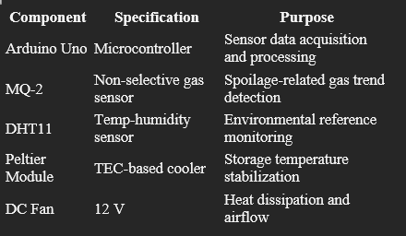

C. Prototype Assembly and Sensor Placement:
All components were assembled inside a sealed plastic enclosure to simulate a controlled food storage environment. The MQ-2 gas sensor was positioned near the centre of the chamber to capture representative gas concentration levels and avoid localized accumulation. The DHT11 sensor was placed away from the Peltier module to minimize thermal bias caused by localized cooling.
The Peltier module was mounted on one side of the enclosure, with its hot side connected to an external heat sink and cooling fan to improve thermal efficiency. Internal airflow was maintained using a fan placed opposite the Peltier surface, ensuring uniform gas distribution throughout the chamber. The enclosure was kept minimally ventilated to allow controlled gas accumulation during experimentation.

D. Data Acquisition and Pre-Processing:
Sensor data was acquired at fixed intervals ranging from one to five minutes, depending on the experimental duration. The MQ-2 gas sensor output was recorded as analog values representing relative changes in gas concentration rather than absolute concentration units. Temperature and humidity readings from the DHT11 sensor were recorded to provide environmental context.
Raw sensor data often contained short-term fluctuations due to sensor noise and environmental disturbances. To reduce this effect, a moving-average filter was applied to the gas sensor data before further processing. This preprocessing step improved trend clarity and stability of the spoilage prediction output.

E. Spoilage Prediction Index (SPI) Computation:
To quantify spoilage progression, a Spoilage Prediction Index (SPI) was formulated based on relative changes in gas sensor output with respect to an initial baseline recorded under fresh food conditions. The SPI represents a normalized indication of spoilage progression, increasing gradually as spoilage-related gas concentration rises over time.
Unlike conventional fixed-threshold approaches, the SPI enables continuous tracking of food condition and early warning generation before visible spoilage occurs. Experimentally defined threshold values were used to classify food condition into safe, warning, and spoilage stages. The SPI was also used to control environmental regulation, with cooling disabled once advanced spoilage was detected.

F. IoT Communication and Data Visualization
The Processed sensor data and SPI values were visualized locally using time-series plots generated from recorded serial data. These plots were used to analyse gas concentration trends and spoilage progression over time. Although real-time cloud communication was not implemented in the current prototype, the system architecture supports future IoT-based remote monitoring and long-term data logging.
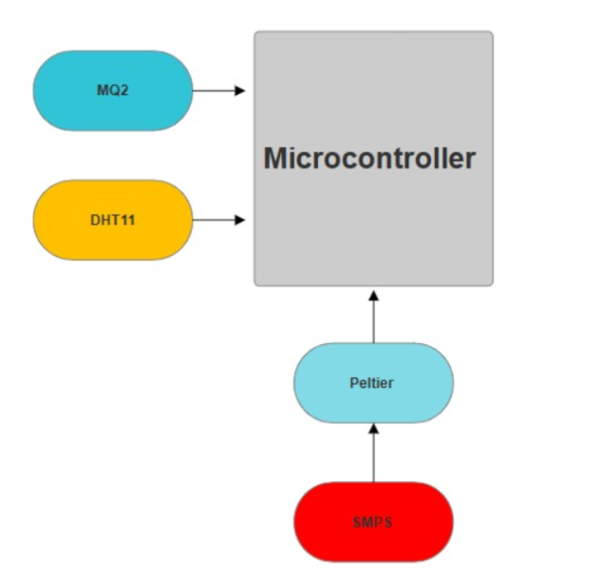Fig. 1 illustrates the system block diagram showing the interaction between sensing, processing, and environmental control units

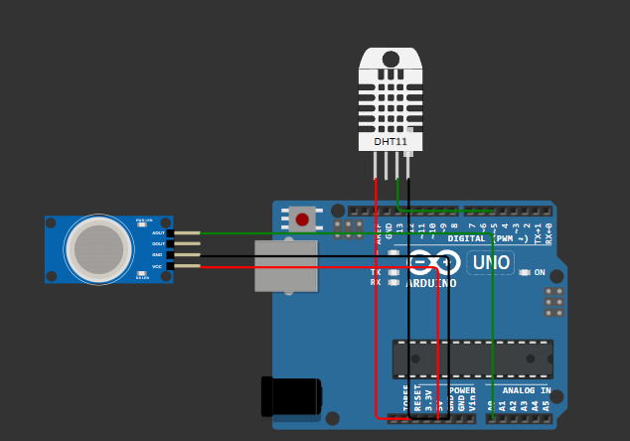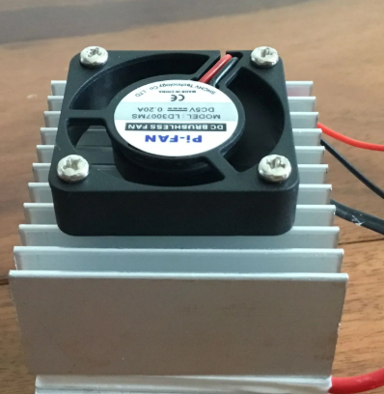Fig. 2 shows the experimental prototype setup and sensor placement inside the storage chamber.

G. Experimental Procedure:
The prototype was evaluated using commonly consumed perishable food items, including bananas, tomatoes, cooked rice, and leafy vegetables. Each food sample was placed inside the storage chamber and monitored continuously for a duration of 24–48 hours under ambient conditions.
Physical spoilage indicators such as odour development, texture changes, and visible degradation were observed manually and recorded. These observations were compared with gas sensor trends and SPI progression to validate early spoilage detection performance.
IV.
A. VOC Sensor Response During Food Storage:
The behavior of the MQ-2 gas sensor was observed under controlled storage conditions to study its response to spoilage-related gaseous emissions from different perishable food items. When fresh food samples were initially placed inside the storage chamber, the sensor output remained relatively stable, indicating minimal microbial activity. As storage time progressed, a gradual increase in sensor output was observed, corresponding to the accumulation of volatile gases produced during microbial metabolism.
Different food categories exhibited distinct gas evolution patterns. High-moisture food items such as cooked rice and leafy vegetables showed a faster increase in gas sensor readings, while fruits such as bananas and tomatoes exhibited a comparatively slower rise. This behaviour is consistent with the known influence of moisture content on microbial growth rates. Importantly, the increase in gas sensor output was observed prior to the appearance of visible spoilage indicators such as odour development, texture softening, or surface discoloration

B. Environmental Conditions Inside the Storage Chamber:
Temperature and humidity within the storage chamber were monitored to provide environmental context during spoilage observation. The Peltier-based cooling mechanism contributed to reduced temperature fluctuations compared to ambient conditions, helping to maintain a relatively stable internal environment. Relative humidity levels varied depending on the food type, with higher values typically observed for high-moisture food samples due to moisture release during storage.
Although temperature and humidity were not used directly for spoilage prediction in the proposed system, their monitoring helped interpret gas sensor behaviour and supported controlled storage conditions. The observed environmental stability contributed to slower spoilage progression and improved consistency in gas accumulation trends. These environmental observations provide supporting evidence for the effectiveness of combining gas-based monitoring with basic thermal regulation.

C. Spoilage Prediction Index (SPI) Trend Analysis:
The Spoilage Prediction Index (SPI) was evaluated as a trend-based indicator derived from relative changes in MQ-2 gas sensor output with respect to an initial baseline recorded under fresh conditions. During the early stages of storage, SPI values remained low, corresponding to minimal gas accumulation and safe food conditions. As spoilage-related gas concentration increased over time, SPI values rose gradually, indicating progressive spoilage development.
A distinct increase in SPI was observed before visible spoilage indicators appeared, highlighting the potential of the SPI for early warning generation. Instead of providing a binary safe-or-unsafe classification, the SPI enabled continuous tracking of spoilage progression. The representative SPI trend over time is shown in Fig. 4, illustrating gradual transition across safe, warning, and spoilage stages. These observations confirm that gas-trend-based indexing is suitable for early spoilage assessment in low-cost monitoring systems.

D Observed Impact of Environmental Control on Spoilage Progression:
The combined use of early gas-based monitoring and basic environmental control demonstrated a noticeable influence on spoilage progression. Temperature stabilization and controlled airflow helped slow microbial activity, resulting in a more gradual increase in gas concentration and SPI values. While the system is not intended to prevent spoilage entirely, the observed trends indicate a delay in degradation when compared to uncontrolled ambient storage.
These observations suggest that integrating early spoilage detection with simple thermal regulation can improve food safety awareness and reduce unnecessary food wastage. The system demonstrates the potential for extending the usable life of stored food by enabling timely intervention based on spoilage trends rather than relying solely on visual inspection.

V. DISCUSSION
A. Interpretation of Gas-Based Spoilage Trends
The observed behaviour of the MQ-2 gas sensor indicates that changes in spoilage-related gaseous emissions can be effectively used as early indicators of food degradation. An increase in sensor output was observed as storage duration increased, suggesting rising microbial activity within the food matrix. This behaviour supports the theoretical understanding that biochemical processes associated with spoilage generate volatile gases prior to visible sensory changes.
Differences in gas accumulation trends among food samples highlight the influence of food composition on spoilage dynamics. High-moisture food items such as cooked rice and leafy vegetables exhibited faster gas accumulation compared to fruits, which is consistent with favourable conditions for microbial growth. These observations demonstrate that gas-trend analysis can differentiate spoilage progression across food categories without requiring selective gas identification.

B. Effectiveness of the Spoilage Prediction Index (SPI)
The Spoilage Prediction Index (SPI) provided a convenient method to represent gradual spoilage progression using relative changes in gas sensor output. Instead of relying on binary threshold detection, the SPI enabled continuous tracking of food condition over time. This trend-based representation allows early-stage spoilage detection before visible degradation becomes apparent.
Although the SPI in the current implementation is derived primarily from gas sensor behaviour, it effectively reflects the underlying biological activity associated with spoilage. The gradual increase in SPI values demonstrates its suitability for early warning generation in low-cost monitoring systems. This approach reduces reliance on subjective assessment methods and improves consistency in spoilage evaluation.

C. Role of Environmental Regulation in Spoilage Control:
Basic environmental regulation using a Peltier-based cooling mechanism contributed to stabilizing storage conditions and slowing spoilage progression. Temperature stabilization reduced rapid microbial activity, while controlled airflow ensured uniform gas distribution within the storage chamber. This combination improved the reliability of gas-based monitoring by minimizing localized gas accumulation and environmental fluctuations.
While the environmental control mechanism does not prevent spoilage entirely, its integration with early detection enables timely intervention. Disabling cooling once advanced spoilage is detected also improves energy efficiency, reinforcing the practicality of combining monitoring with selective preservation rather than continuous cooling.

D. Practical Implications for Small-Scale Applications:
The proposed system is well suited for household and small-scale food storage environments where continuous manual inspection is impractical. The use of low-cost components, simple processing logic, and gas-based trend analysis makes the system accessible and scalable. Early awareness of spoilage progression allows informed decisions regarding food consumption or disposal, thereby enhancing food safety and reducing waste.
From a biosafety perspective, early detection reduces the likelihood of consuming spoiled food and supports proactive food management. The system demonstrates how simple sensing and processing techniques can improve storage awareness without requiring complex infrastructure.

E. Observed Limitations:
Certain limitations were identified during prototype-level evaluation. The MQ-2 gas sensor is non-selective and responds to a mixture of volatile and combustible gases, which may result in variations in output depending on food type and environmental conditions. Sensor drift over extended operation may also affect long-term accuracy, indicating the need for periodic recalibration.
Additionally, the cooling efficiency of the Peltier module is influenced by ambient temperature and enclosure insulation quality. These factors may impact system performance under varying environmental conditions. Despite these limitations, the system demonstrates functional feasibility and provides a foundation for further refinement.

VI. CONCLUSION
This work presented the design and prototype-level evaluation of a biosafe food spoilage monitoring and preservation system based on volatile gas sensing and basic environmental control. The study demonstrated that food spoilage is associated with measurable increases in spoilage-related gaseous emissions that occur prior to visible degradation. Monitoring these gas trends enables early identification of spoilage progression.
The introduction of a Spoilage Prediction Index (SPI) allowed relative changes in gas sensor output to be translated into a continuous indication of food condition. This trend-based approach provides an advantage over conventional storage methods that rely on passive preservation and subjective assessment. The integration of a Peltier-based cooling mechanism further supported storage stability and delayed spoilage progression.
Overall, the proposed system confirms that low-cost gas sensors, simple processing techniques, and controlled storage environments can be effectively combined to improve food safety awareness. The system is suitable for small-scale applications and serves as a practical foundation for intelligent food storage solutions.

VII. LIMITATIONS AND FUTURE WORK:
Although the proposed system demonstrated effective trend-based spoilage monitoring, several limitations remain. The non-selective nature of the MQ-2 gas sensor limits the ability to identify specific spoilage-related compounds. Sensor drift and sensitivity variations over long-term operation also highlight the need for periodic calibration.
Future work will focus on incorporating selective gas sensor arrays or additional sensing modalities to improve detection reliability. Data-driven or machine learning–based models may be explored to enhance SPI formulation and adapt thresholds dynamically for different food types. Improvements in enclosure insulation and power management will be considered to enhance thermal efficiency.
The system architecture is designed to support future IoT-based remote monitoring and cloud data visualization, enabling long-term logging and real-time alerts. Extended testing with diverse food samples and longer observation durations will be conducted to further validate robustness and scalability.

